# Azure Multi Factor Authentication

# 

## **Tutorial**

In this tutorial we will create a new directory, a user in the directory and enable MFA on that user.

Type Azure Active Directory in the search bar and select it.

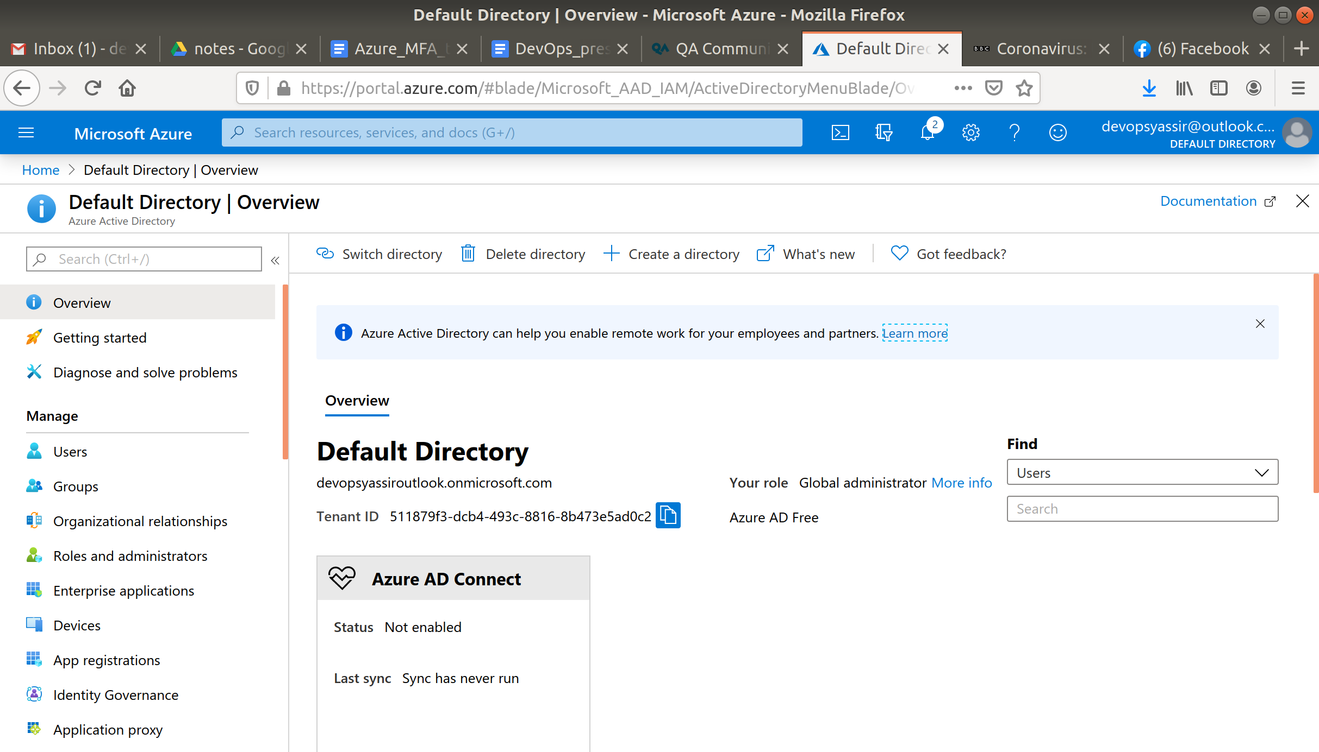

Click + Create Directory and enter the following:

* Directory Type - Azure Active Directory

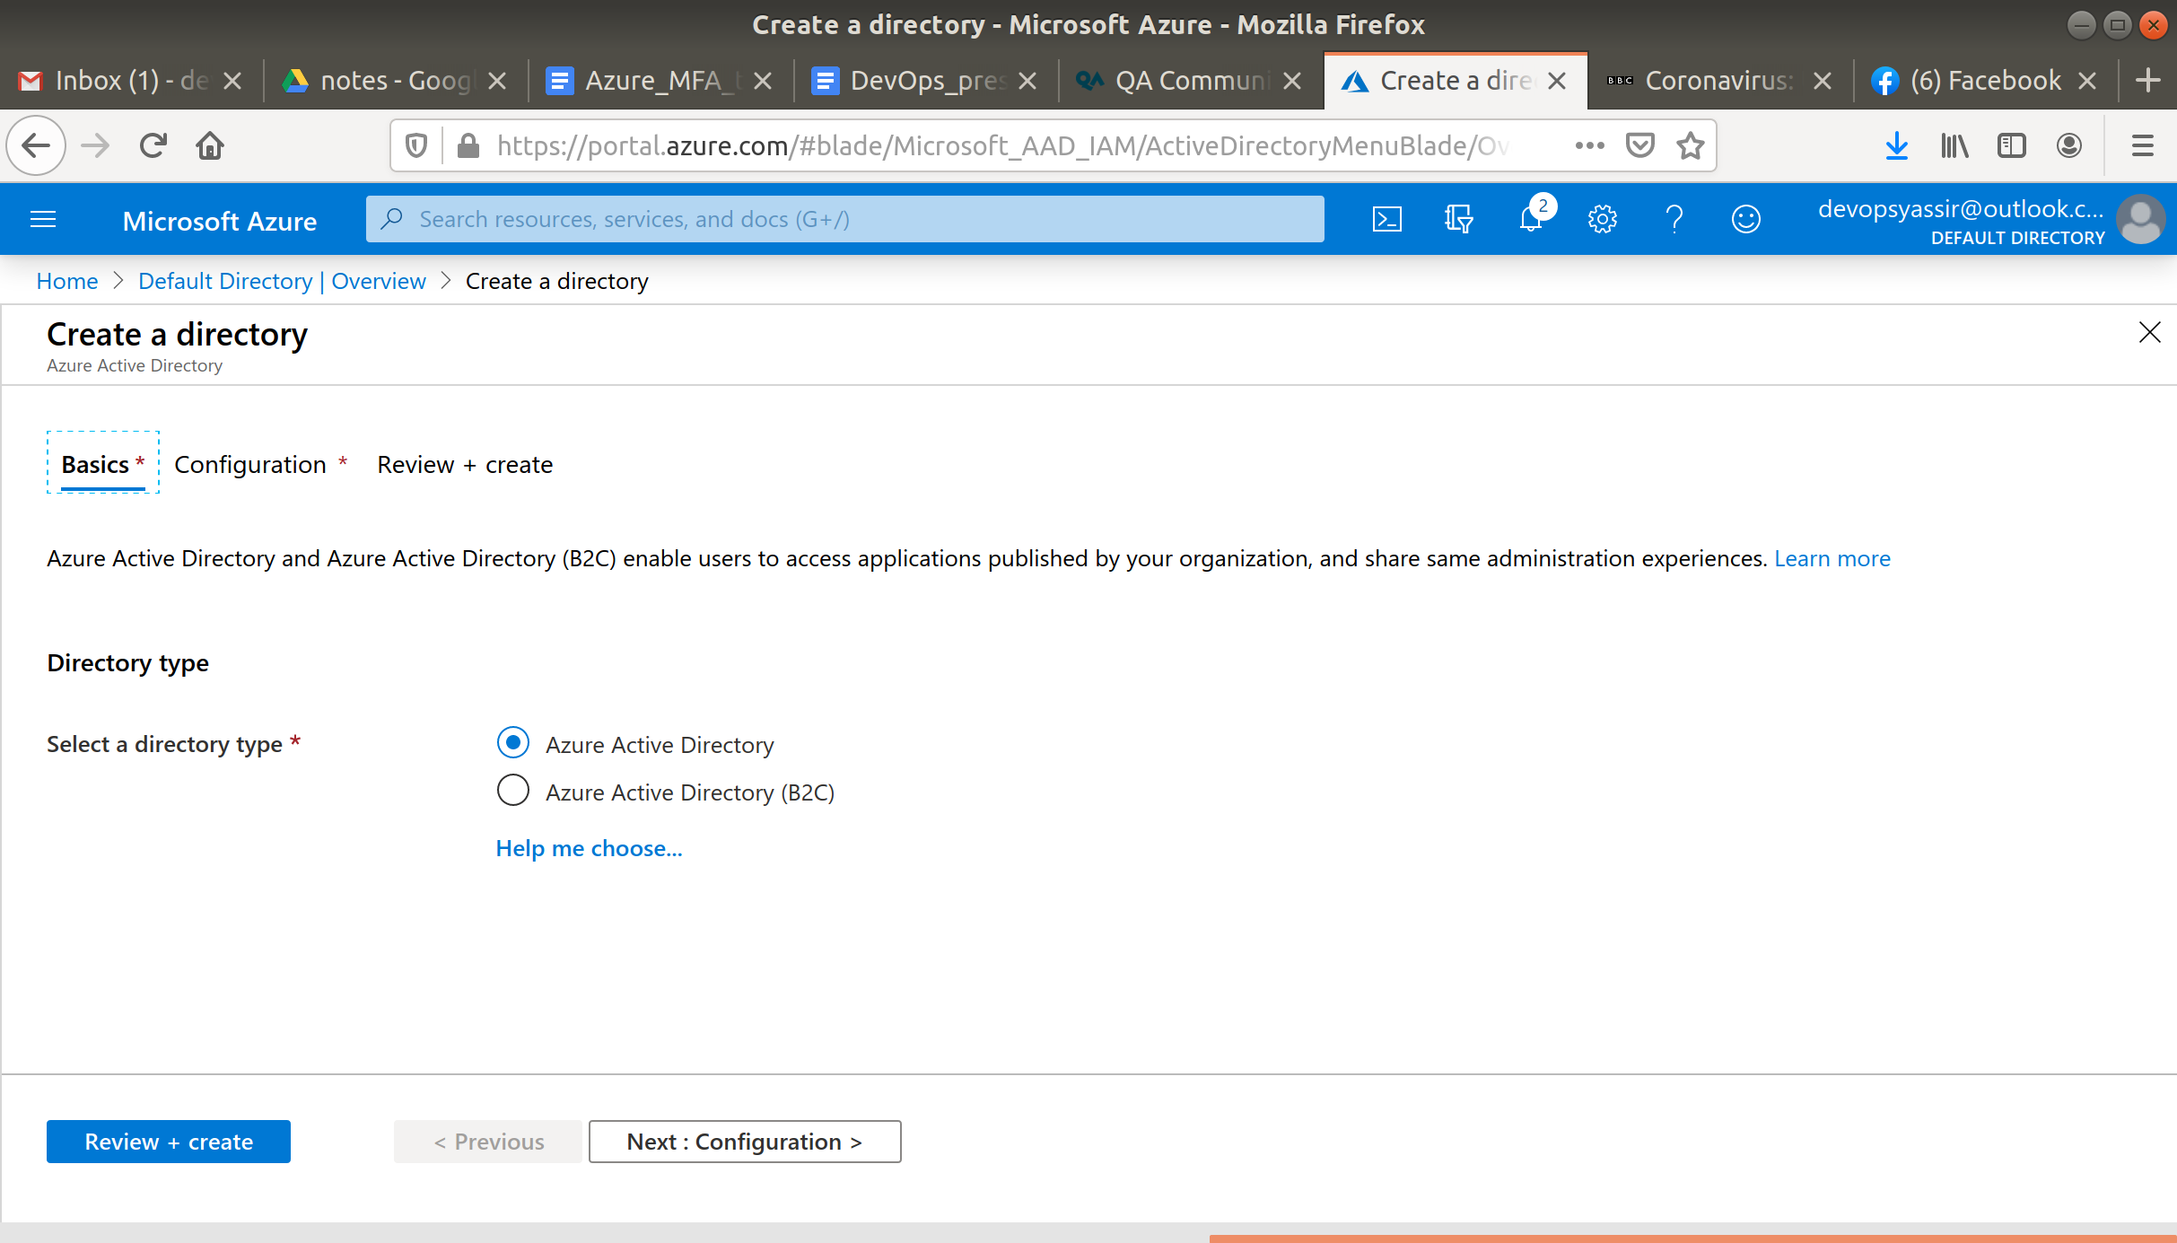

Now under the Configurations tab:

* Organization Name - Anything you like
* Initial domain name - Anything (must be unique)
* Country/Region - United Kingdom

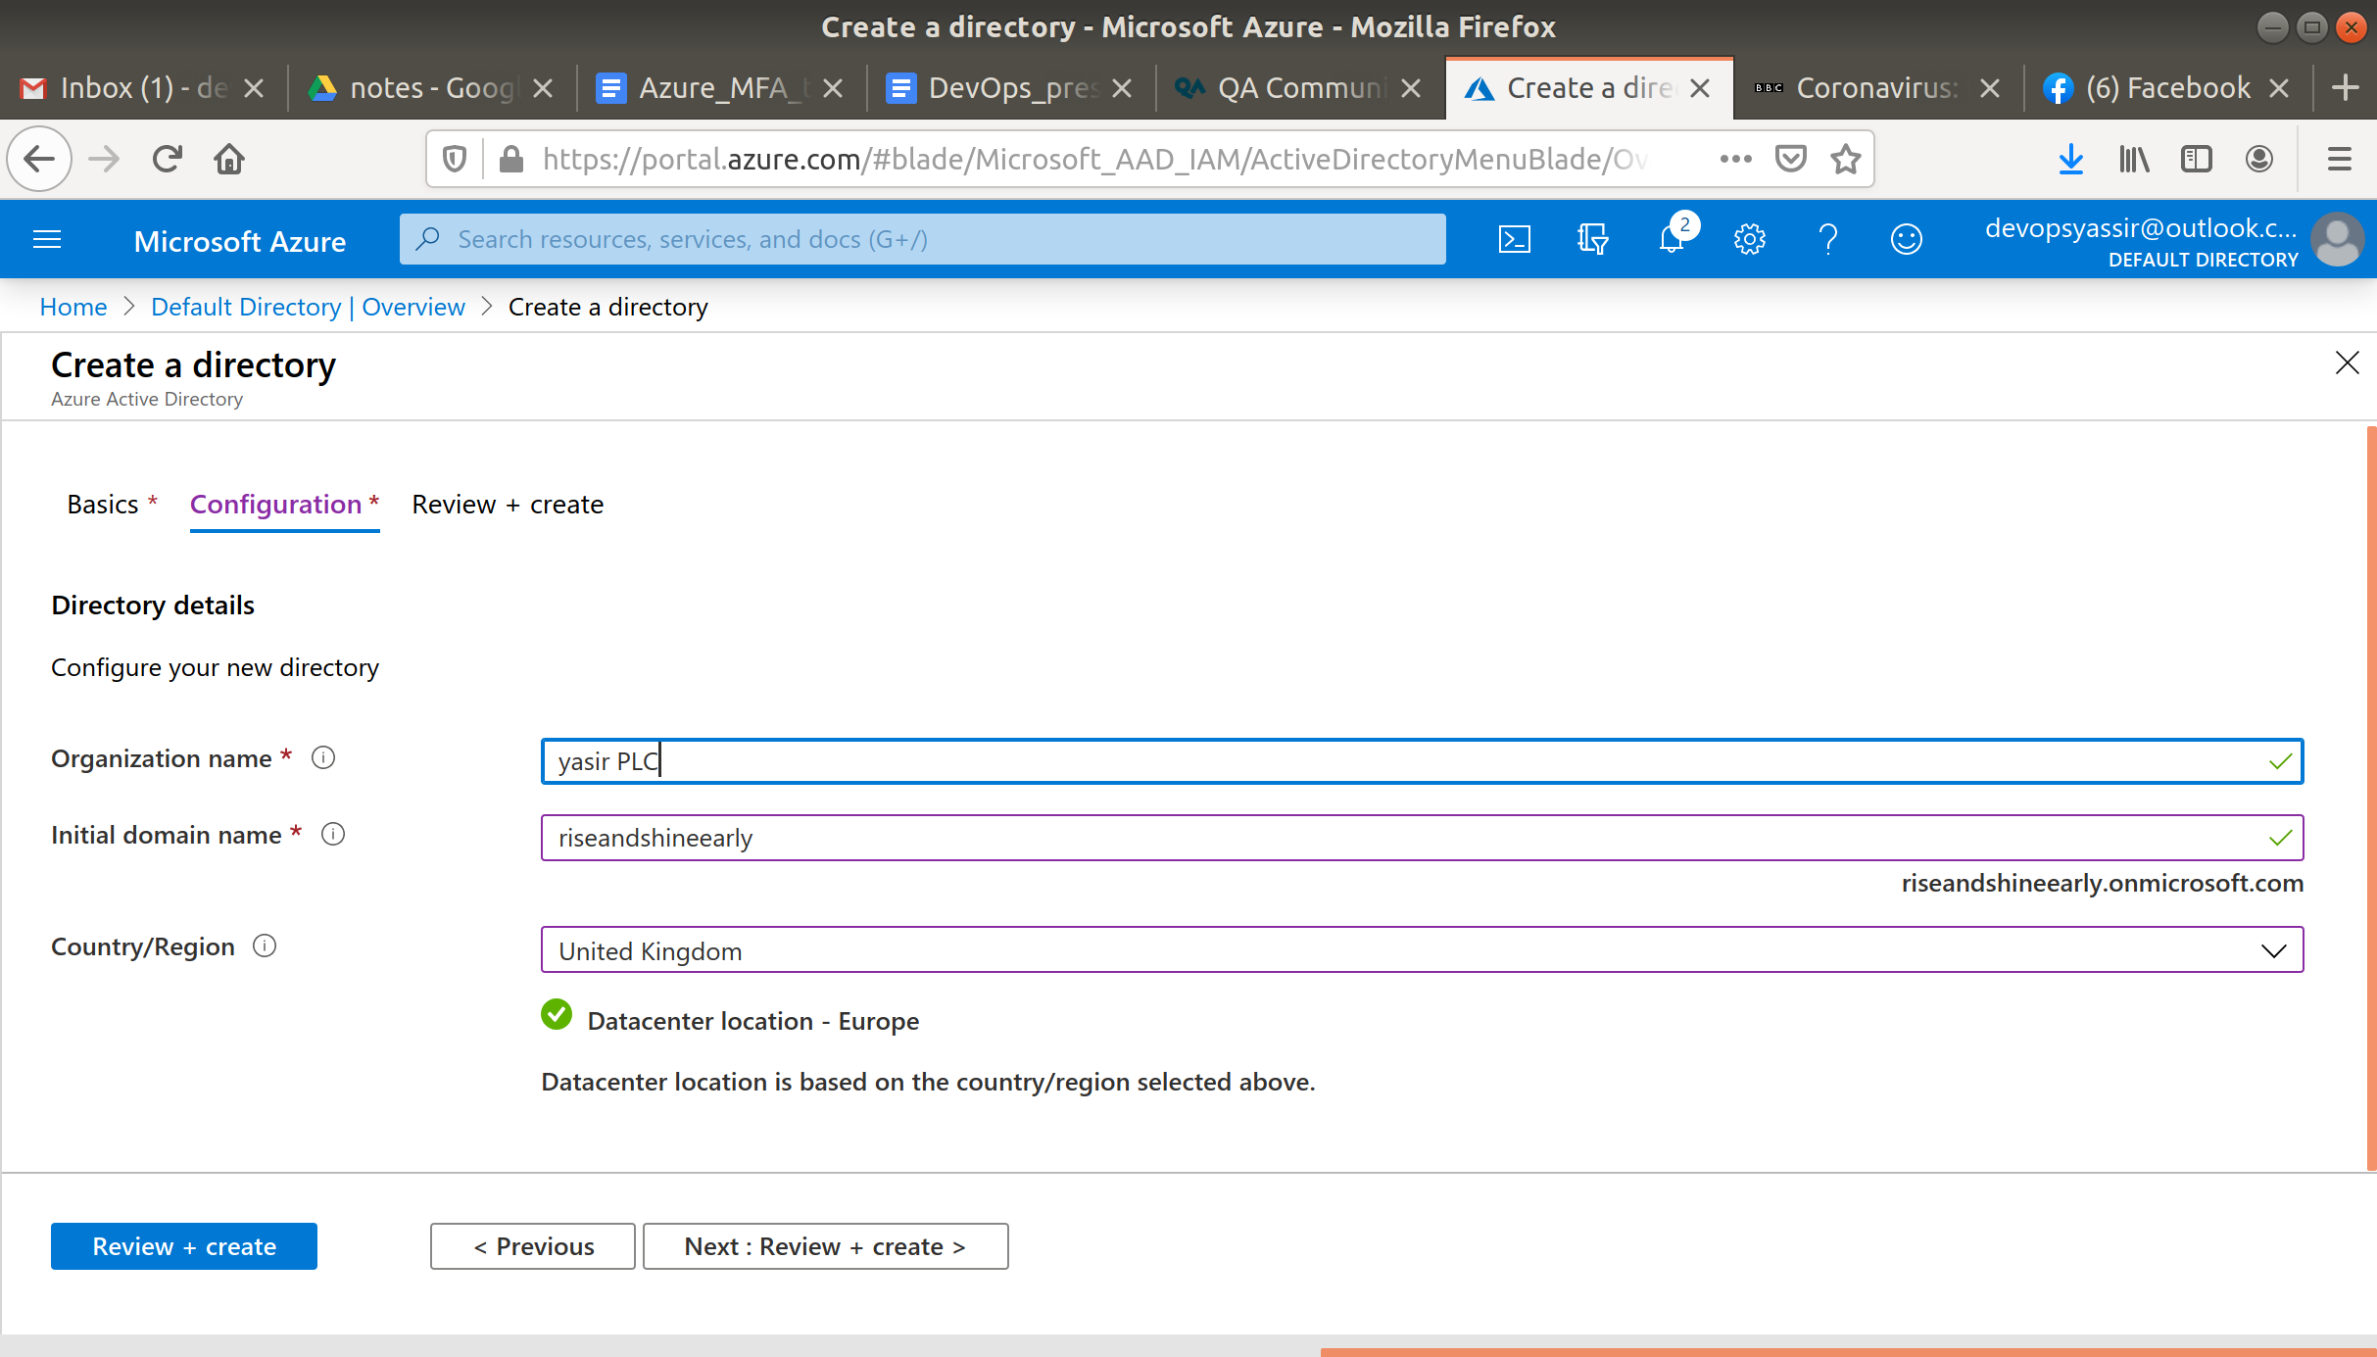

Click Review and Create and then Create.

This may take a while to finish but when it does click Switch Directory

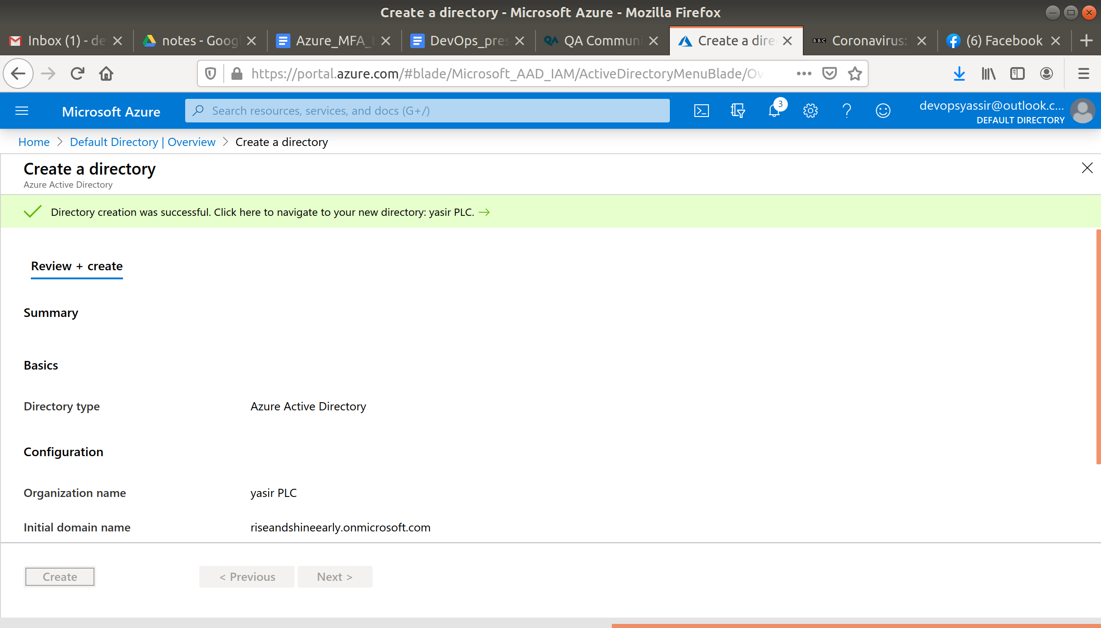

In the new window select your new directory.



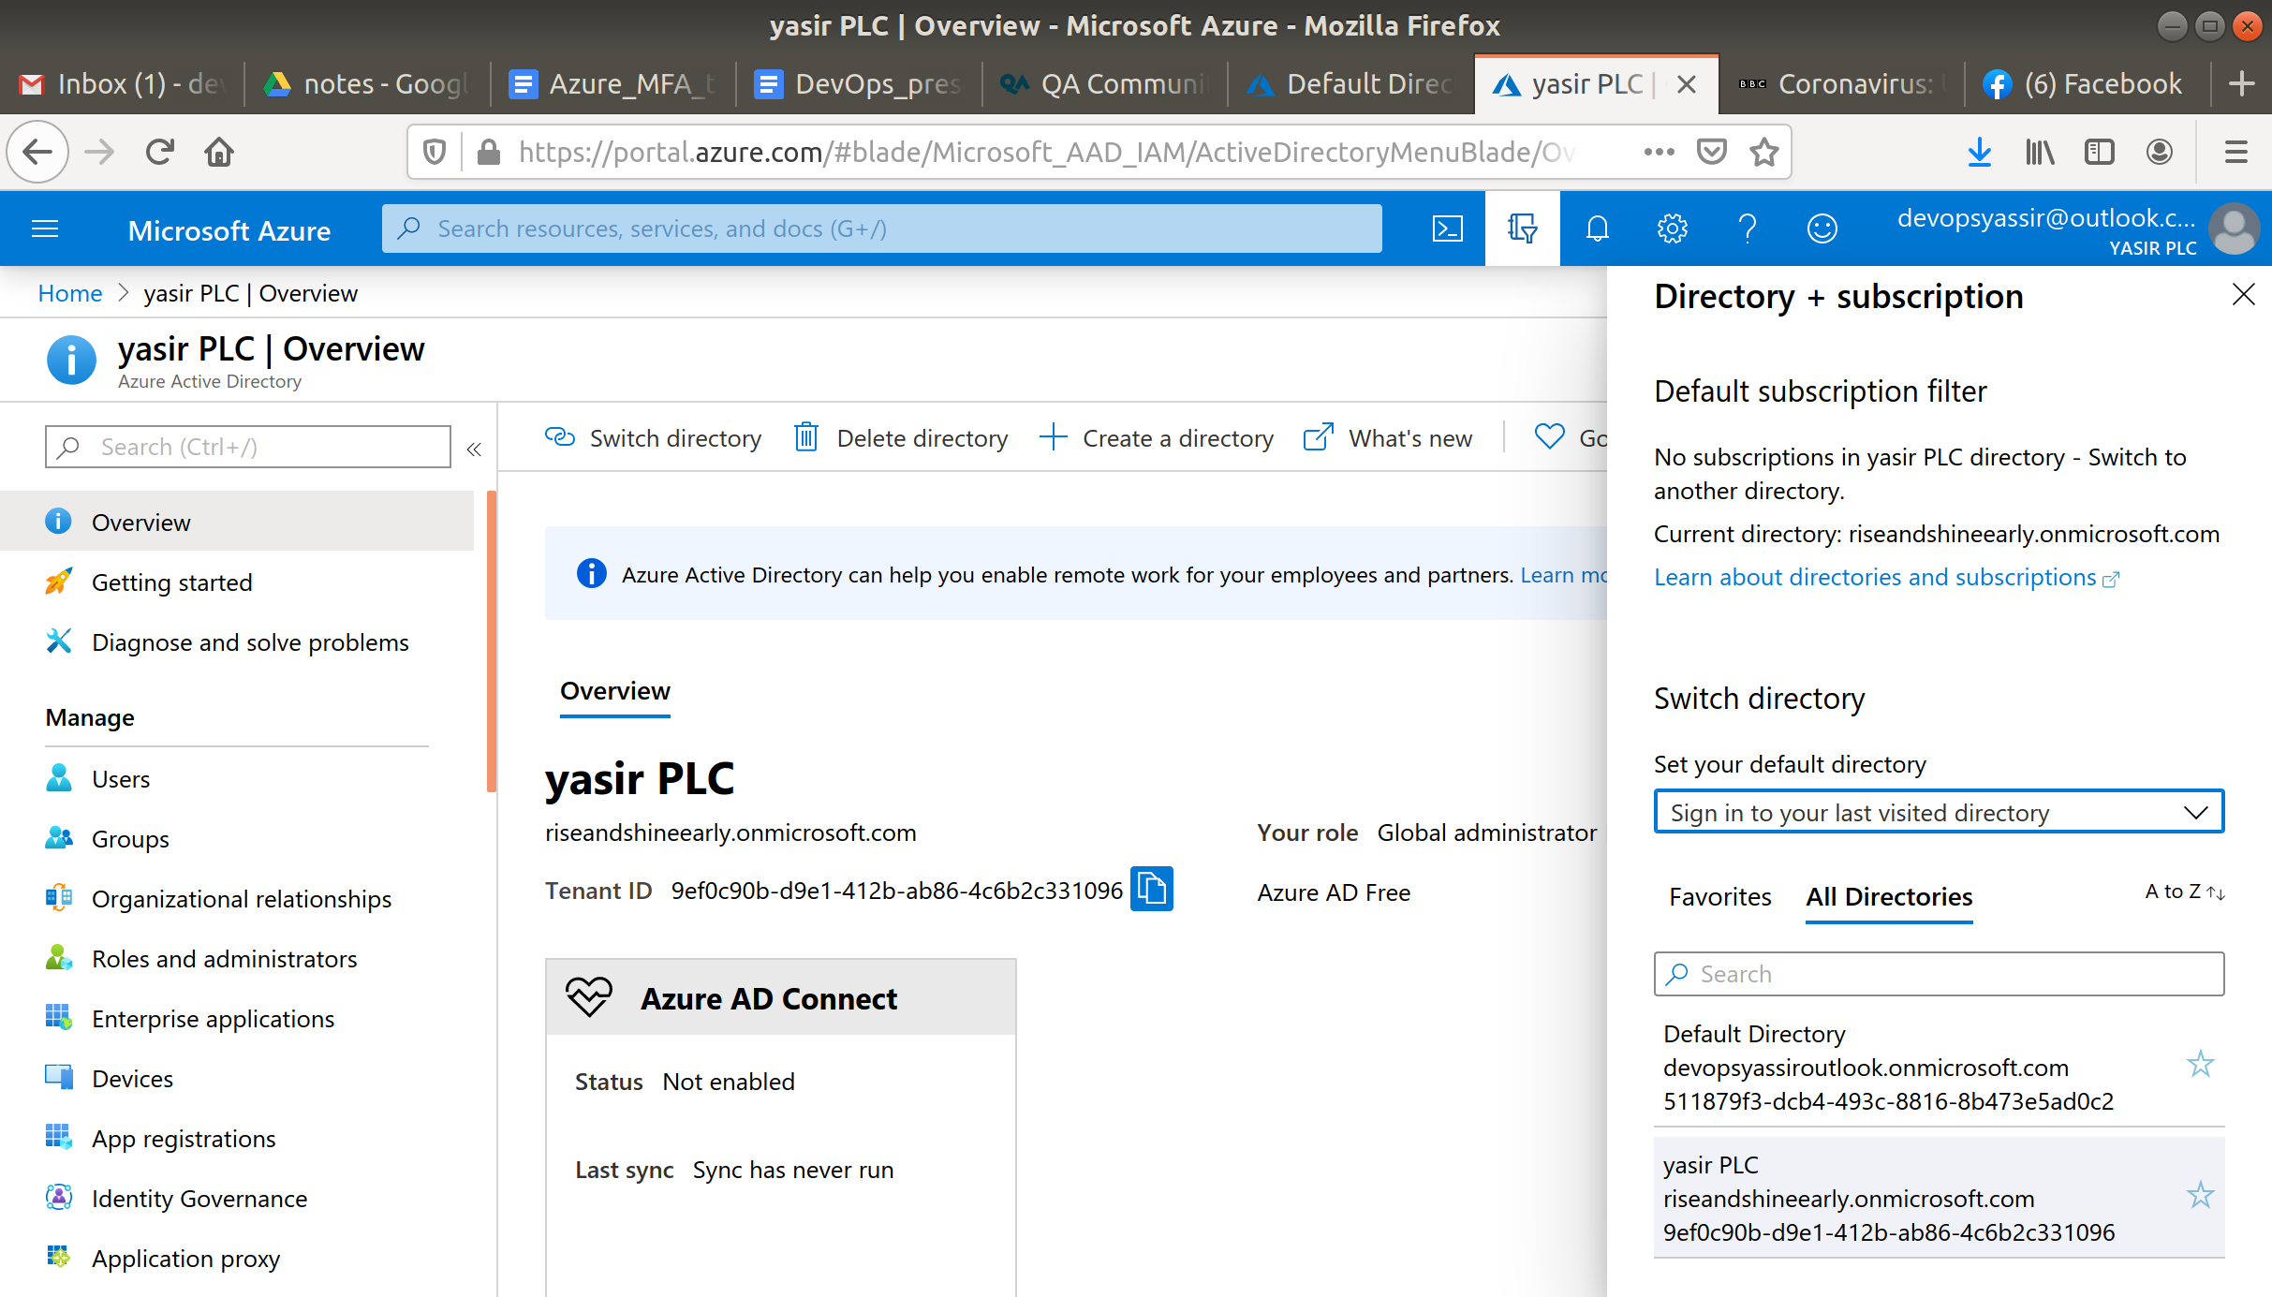

Now in the left blade select Users.

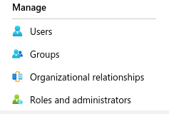

Click +New User, select Create User and enter a user name and name.

And in the Initial Password field, select Show Password and save this for later. Then click Create. Lajo9778

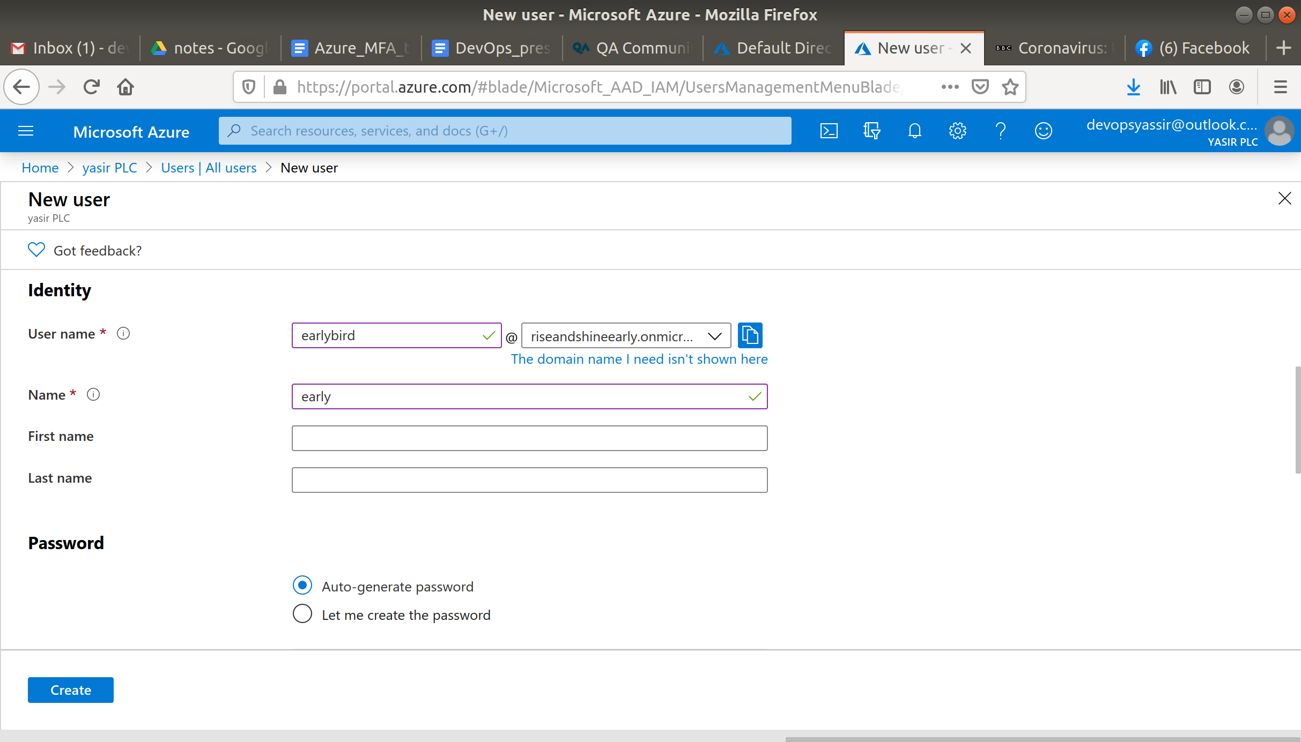

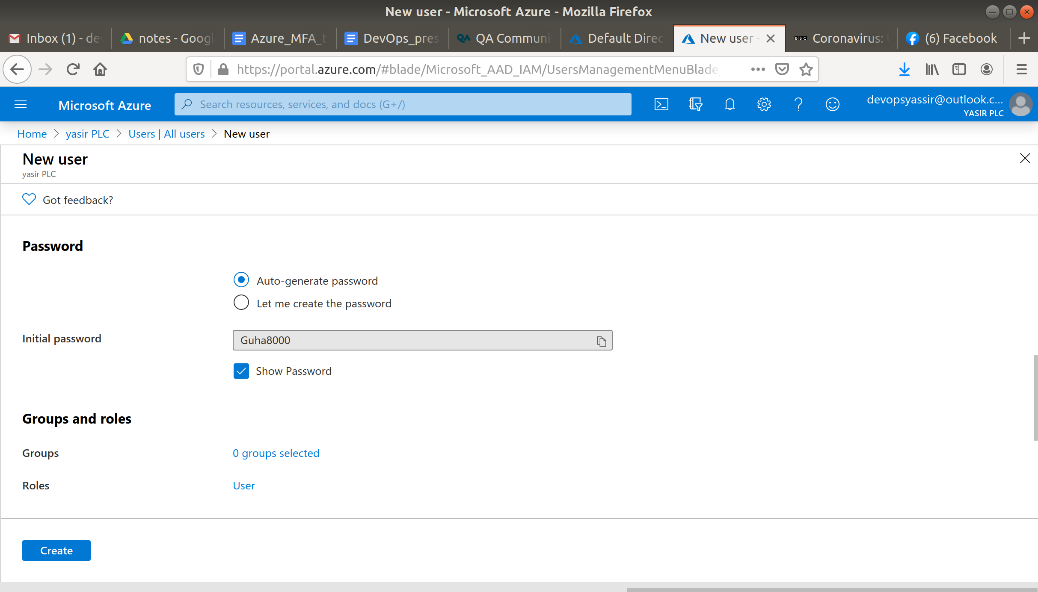

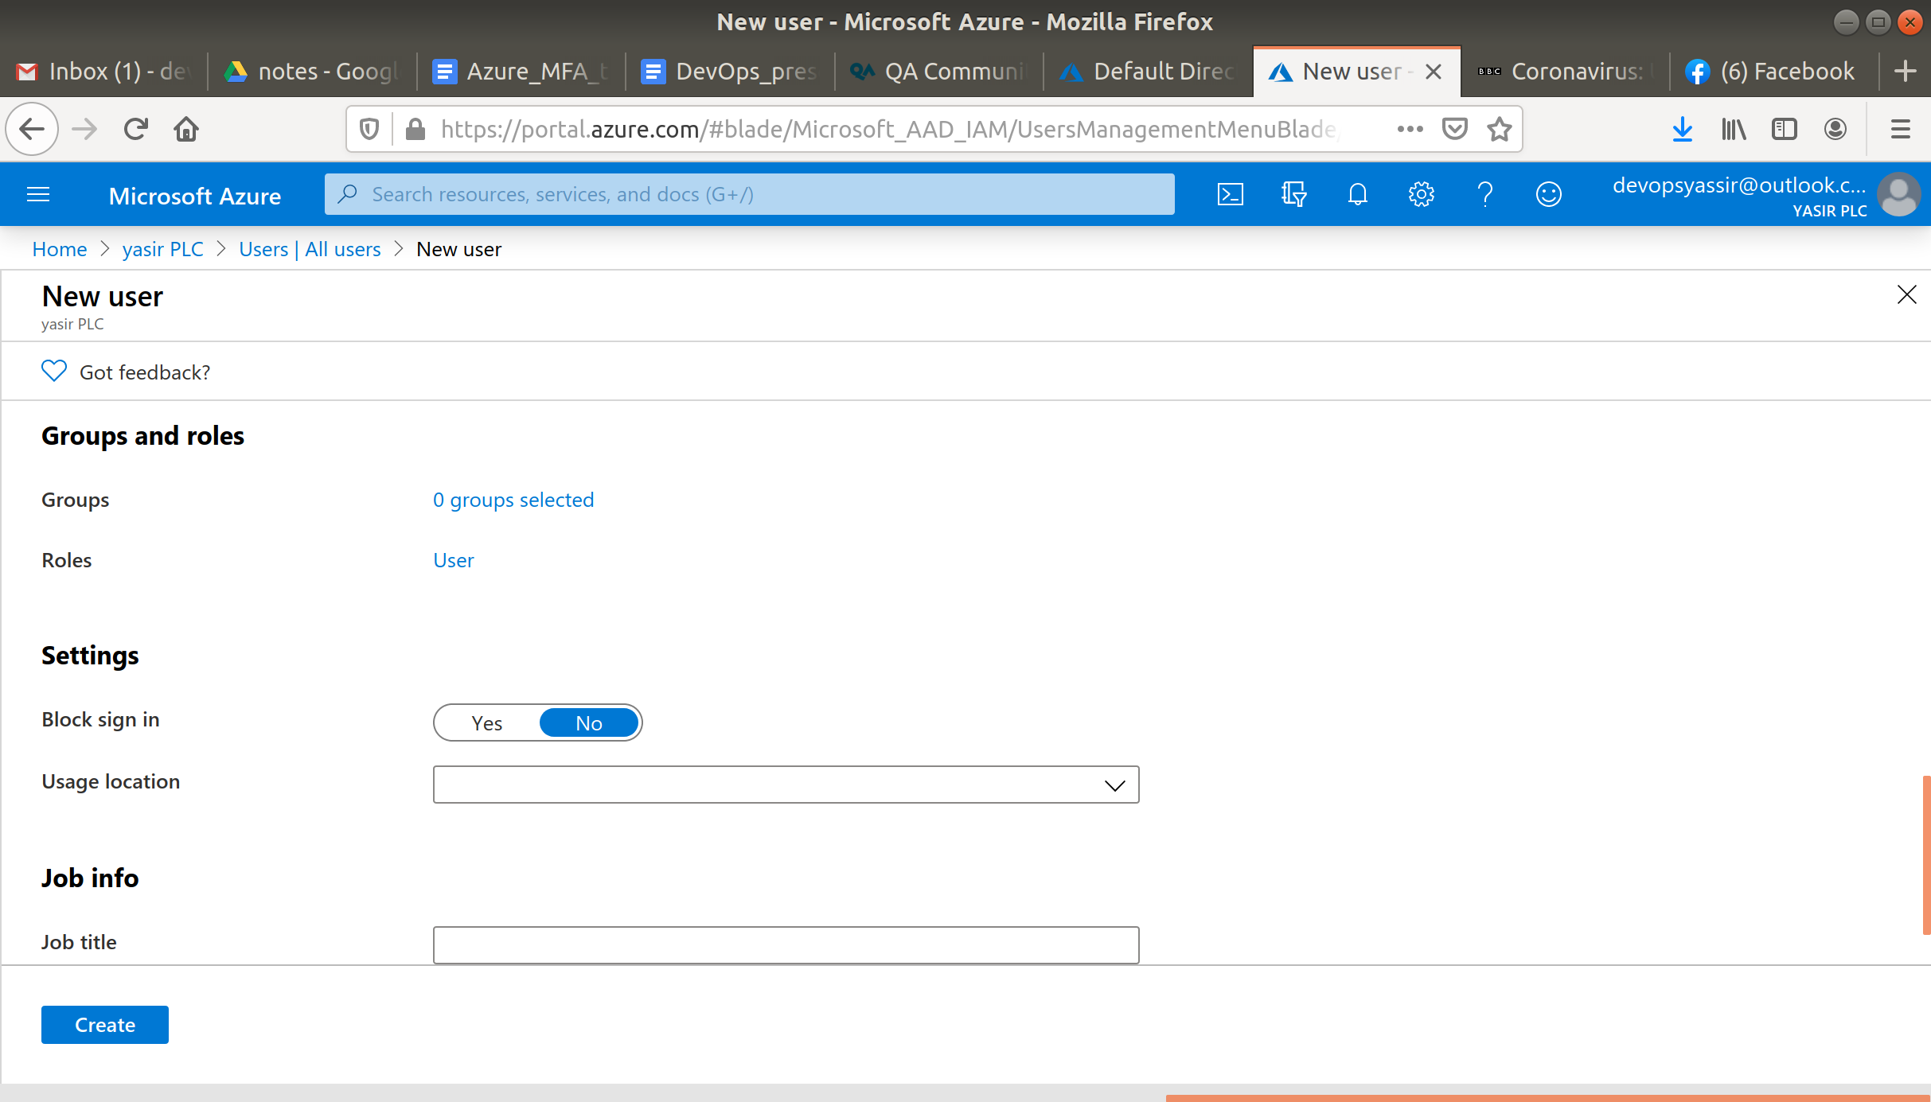

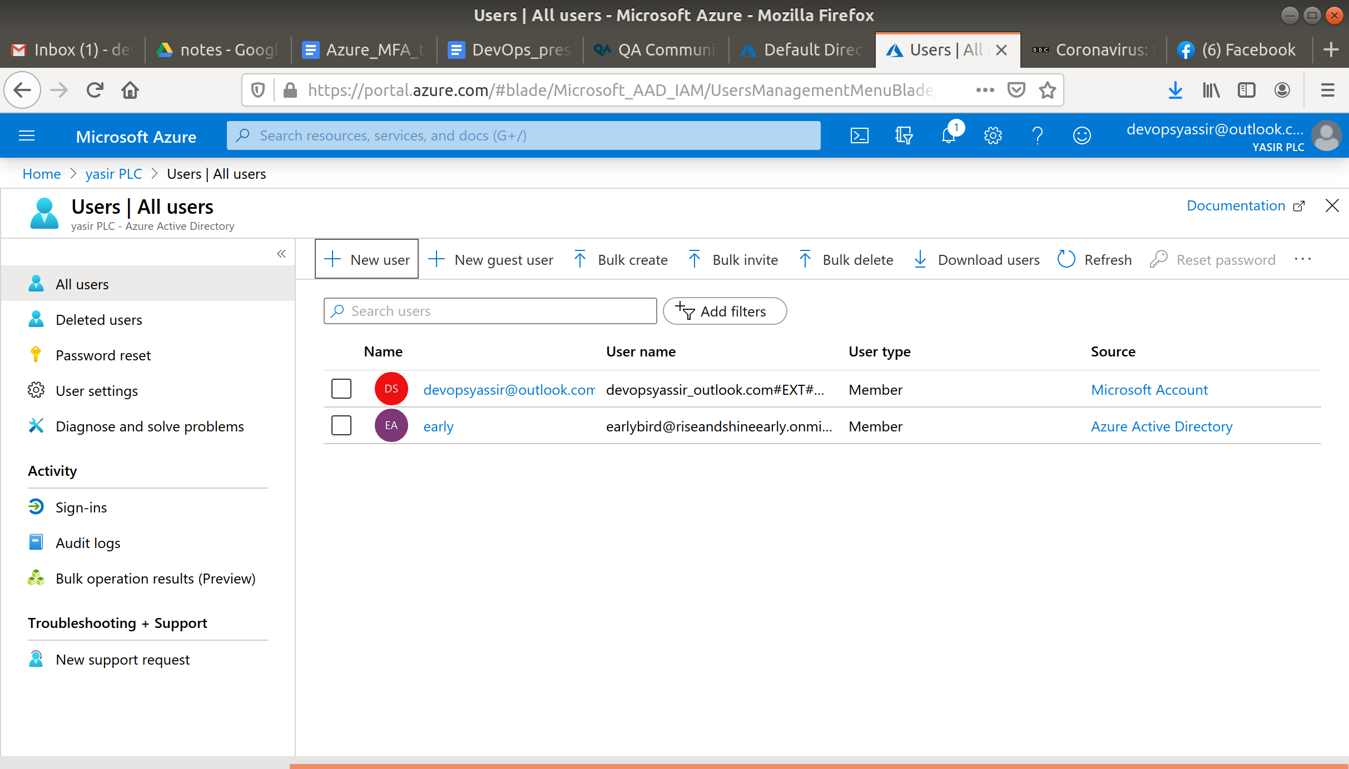

Now on the users page click Multi-Factor Authentication.

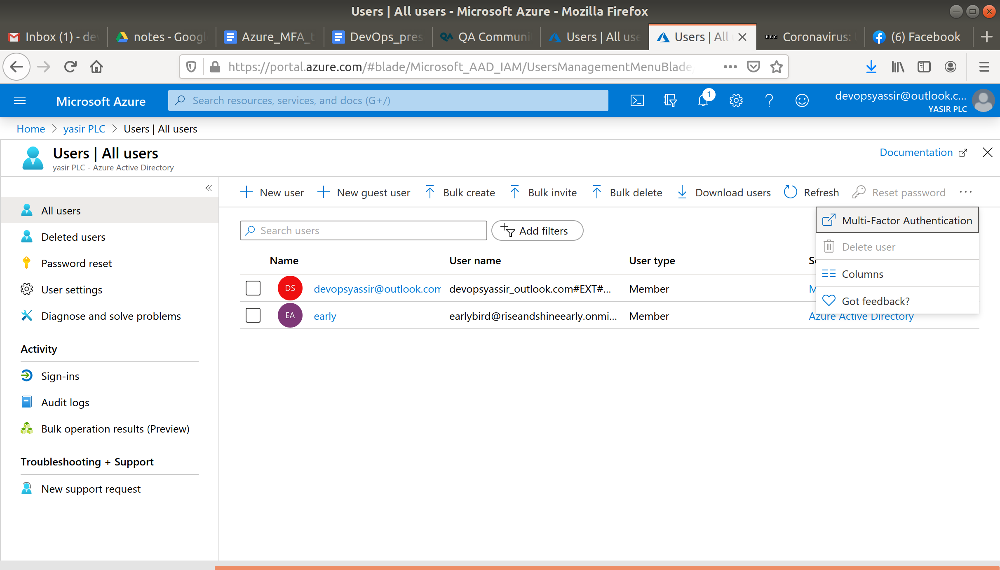

In the new window, you can see the button Bulk Update for many users at once.

But for now select your new user and click Enable.

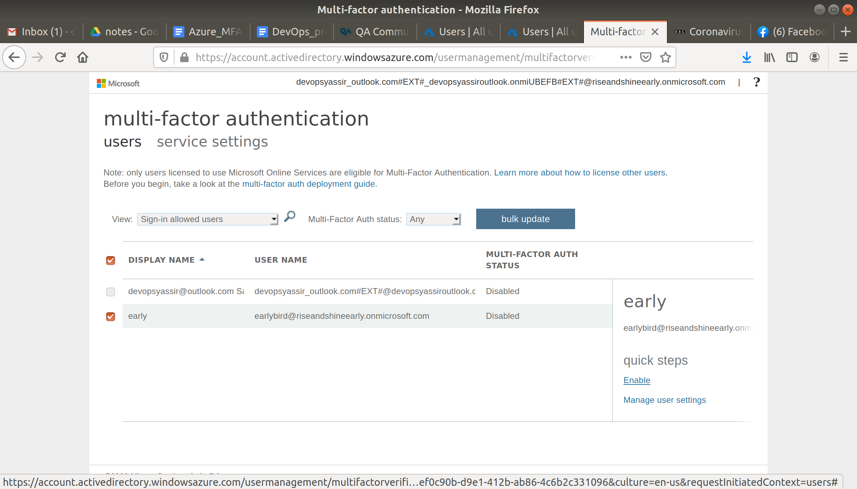

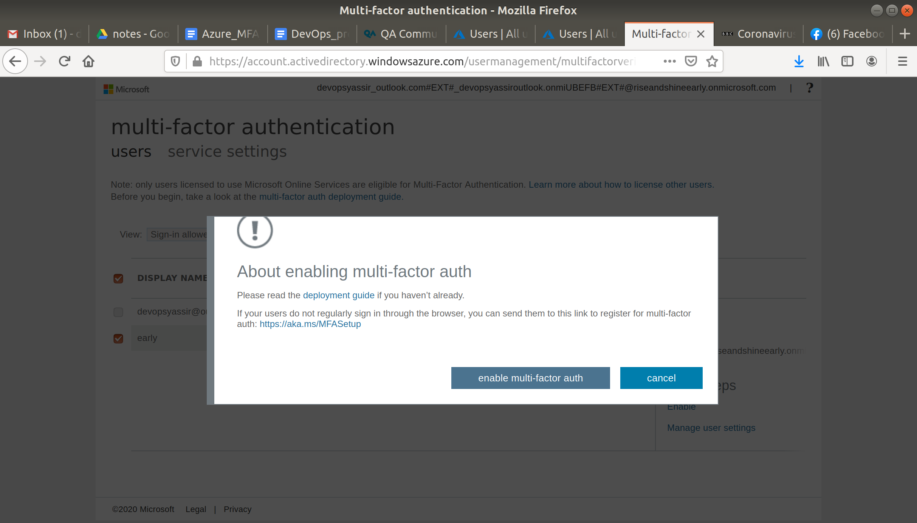

Now create a new tab with the portal and sign out of your account. Then sign in as your new user with the password you saved.

You will then be prompted to enter a second form of verification which will be a phone number.

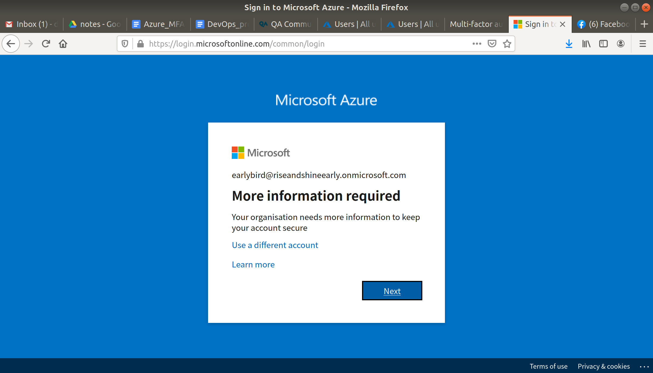

Enter your phone number and wait for a text of Microsoft. Enter the code and click Finished.

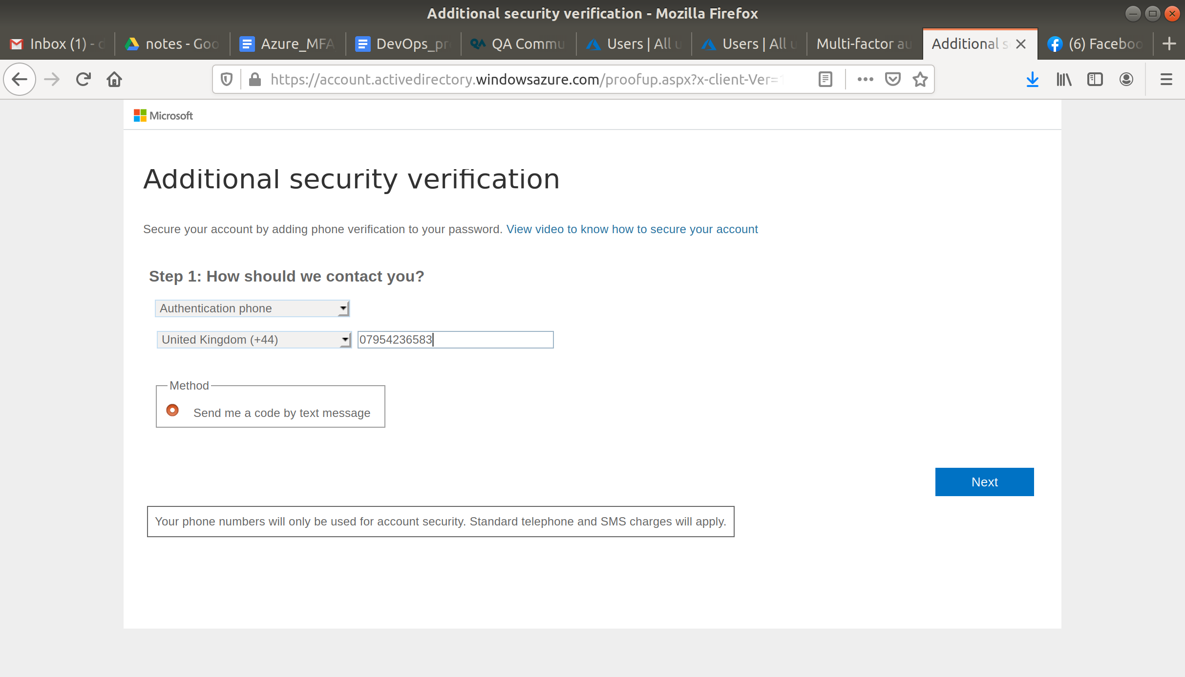

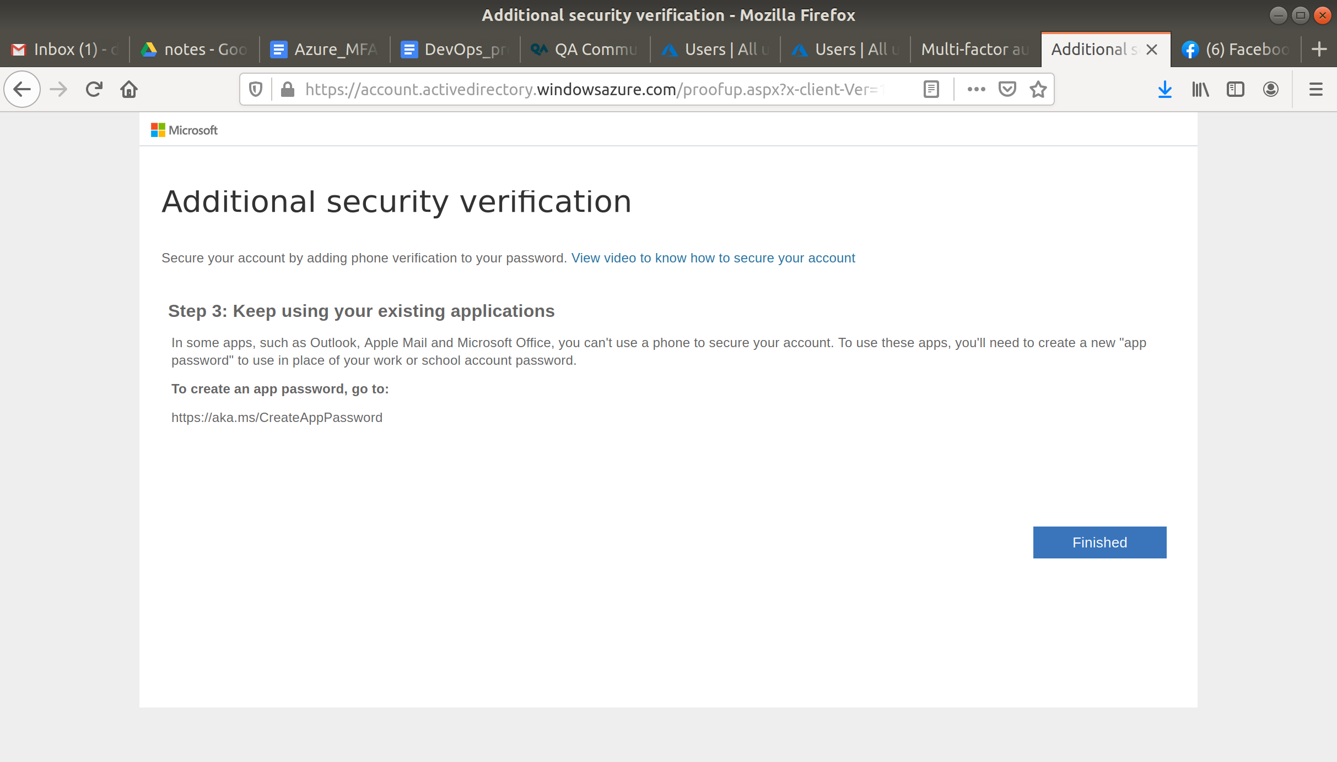

You will then be prompted to update your password. You can then log in as your new user.

Now this user will require 2 step verification to gain access to the portal.

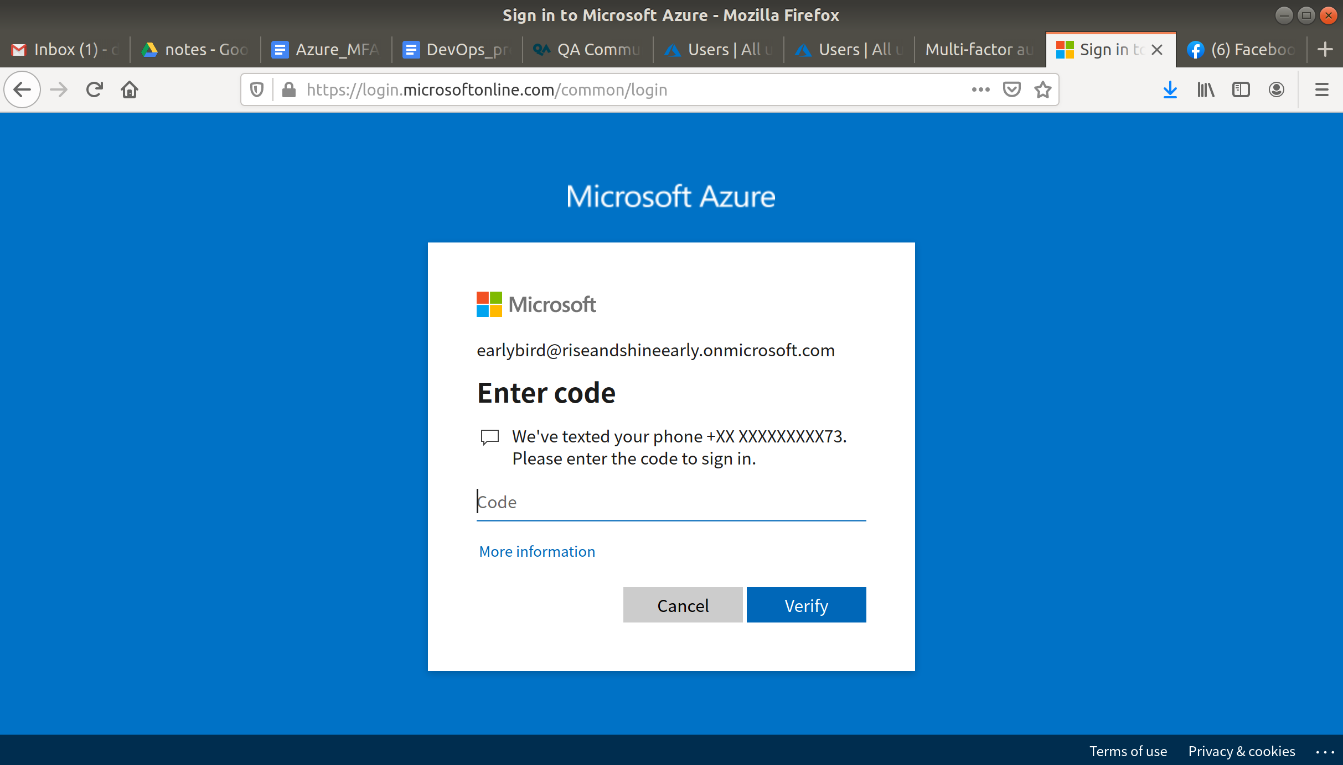

Finally, go back to your main user and on the AAD page click Delete Directory. And complete the actions required to delete the directory.

